ENVIRONMENTAL IMPACT ANALYSIS & CLIMATE CHANGES
Submitted By - Konda Swetha
Date – 20/01/2026
Batch – Data Analysis (07)
Tools Used – Excel, Power BI, Dax, Power Query

1. Introduction
Environmental pollution and climate change are critical global challenges. Analyzing air quality and climate data helps understand pollution trends and supports data-driven decision-making. This project uses Excel and Power BI to transform raw environmental data into meaningful insights through interactive dashboards.

2. Objective of the Project
The main objectives of this project are: - To clean and prepare raw environmental and climate data - To design a star schema data model - To create calculated columns and DAX measures - To develop interactive Power BI dashboards - To analyze pollution trends and climate impact

3. Data Description
The dataset consists of approximately 1000 rows of raw environmental data, including: - Date information (year, month, day) - Location details (city, state, country) - Pollutant information (PM2.5, PM10, NO2, SO2, CO, O3) - AQI values and categories - Climate parameters such as temperature and rainfall

4. Data Cleaning and Preparation
The raw data contained missing values, inconsistent formats, and duplicates. The following steps were performed using Power Query: - Removal of duplicate records - Handling missing values using average/forward fill methods - Standardizing date and text formats - Creating derived columns such as AQI Category

5. Data Modeling (Star Schema)
A star schema was designed for efficient analysis: - Fact Table: Fact_Climate_Observation (AQI, pollutant values, temperature, rainfall) - Dimension Tables: Dim_Date, Dim_Location, Dim_Pollutant Relationships were created using one-to-many cardinality from dimension tables to the fact table.

6. Calculated Columns and Measures
Key DAX measures created include: - Average AQI - Maximum AQI - Minimum AQI - Total Observations - Average Pollutant Levels Calculated columns such as Year, Month, and AQI Category were also created for filtering and grouping.

7. Dashboard and Visualization
Multiple report pages were created in Power BI: - Overview Dashboard with KPI cards - City-wise Pollution Analysis - Pollutant-wise Analysis - Time-based AQI Trends Visuals used include bar charts, line charts, cards, maps, and slicers.

8. Key Insights

9. Tools and Technologies Used
Microsoft Excel (raw data handling)
- Power BI Desktop
- Power Query
- DAX (Data Analysis Expressions)

10. Conclusion
This project demonstrates how raw environmental data can be transformed into actionable insights using Power BI. The dashboards provide a clear understanding of pollution patterns and support environmental awareness and policy planning.

11. Future Scope
- Integration of real-time pollution data APIs
- Predictive analysis using machine learning
- Expansion to include more cities and climate parameters
- Publishing dashboards to Power BI Service

Problem Statement:
Environmental Pollution & Climate variability are major concerns affecting public health and sustainability.
Raw environmental data is often large, inconsistent, and difficult to analyze without proper modelling. This project aims to clean, model, and visualize air quality and climate data to derive meaningful insights using Power BI.

Data Description:
The dataset contains environmental and climate observations with approximately 1000 rows.
Dataset consists of (AQI value, Temperature, Rainfall (mm), Date, City/Location, Pollutant, Data Source).
Data Cleaning and Transformation:
Data cleaning was performed using Excel and Power Query.
Steps:
- Remove Duplicate Records
- Handled missing values using average/median and logical defaults
- Corrected data types
- Standardized city pollutant names
- Created surrogate keys for dimensions

Data Modeling (Star Schema):
A star schema model was implemented for optimized performance and easy analysis.

Fact Table:
- AQI Value
- Temperature
- Rain mm
- Location Key
- Pollution Key
- Source Key

Dimension Tables:
- Dim Date
- Dim Location
- Dim Pollutant
- Dim Source
techniques. The dashboard helps analyze air quality trends, city-wise pollution levels, 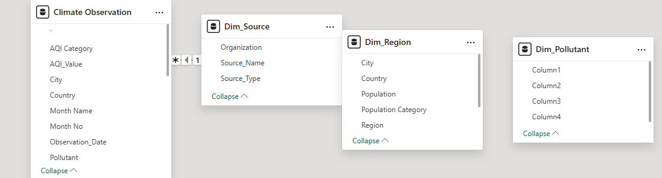

This data model consists of one fact table surrounded by multiple dimension tables, enabling efficient filtering and aggregation. “This project focuses on analyzing environmental pollution and climate patterns using Power BI. I started with raw air quality and climate data containing around 1000 records. The first step was data cleaning, where I handled missing values, removed duplicates, standardized city and pollutant names, and ensured correct data types.
Next, I implemented a star schema data model. I created a central fact table containing measurable values like AQI, temperature, and rainfall, and connected it to dimension tables such as date, location, pollutant, and data source using one-to-many relationships.
I then created DAX measures to calculate KPIs like average AQI, maximum AQI, and total rainfall. Using these measures, I designed interactive dashboards with KPI cards, trend charts, city-wise comparisons, pollutant analysis, and map visuals.
The dashboard helps identify high-pollution cities, dominant pollutants like PM2.5, seasonal AQI trends, and the impact of rainfall and temperature on air quality.”

Measures (Dax):
Key measures were created for analysis:
- Average AQI
- Maximum AQI
- Average Temperature
- Total Rainfall
- Pollution Contribution%
- AQI Category
Dashboard Design & Visualisations:
The Power BI Consists of multiple pages:
Pages Titles:
- Environment & Climate Overview
- Air Quality Trends Analysis
- City-Wise Pollution Analysis
- Pollutant Contribution Analysis
- Climate Impact on Air Quality
- Geographical Pollution Analysis

Visual Used
- KPI Cards
- Line Charts
- Bar & Column Charts
- Maps
- Scatter Plots
- Table
- Tree map
- Funnel Chart
- Slicers
- Donut and Pie Chart
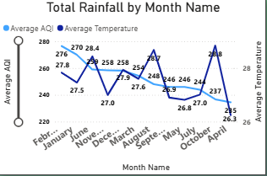

It is a Clustered Column chart, it shows average AQI by Pollutant

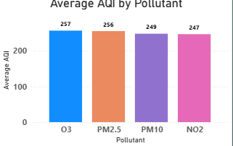

It is a Donut chart, it shows Pollutant Contribution%

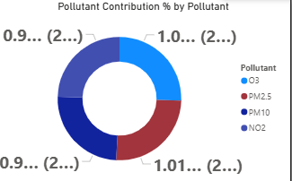

This is a Pie Chart , it shows the AQI Category

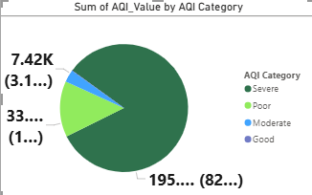

Map shows average AQI and Total Ranifall by city

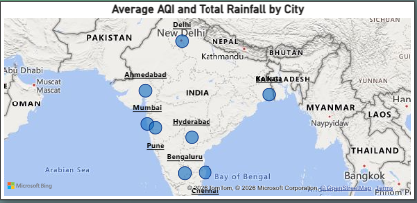

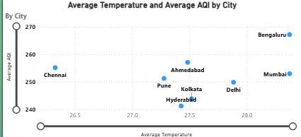
It is a Scatter chart it shows average temperatue and average AQI by city

Table shows the Average AQI And Average Temperature by City

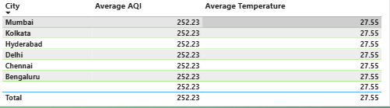

“This project focuses on analyzing environmental pollution and climate patterns using Power BI. I started with raw air quality and climate data containing around 1000 records. The first step was data cleaning, where I handled missing values, removed duplicates, standardized city and pollutant names, and ensured correct data types.
Next, I implemented a star schema data model. I created a central fact table containing measurable values like AQI, temperature, and rainfall, and connected it to dimension tables such as date, location, pollutant, and data source using one-to-many relationships.
I then created DAX measures to calculate KPIs like average AQI, maximum AQI, and total rainfall. Using these measures, I designed interactive dashboards with KPI cards, trend charts, city-wise comparisons, pollutant analysis, and map visuals.
The dashboard helps identify high-pollution cities, dominant pollutants like PM2.5, seasonal AQI trends, and the impact of rainfall and temperature on air quality.”

FUTURE SCOPE OF THE PROJECT
This Environment and Climate Analysis project can be further enhanced and expanded in several ways to provide deeper insights and real-time decision support.

- Real-Time Data Integration
In the future, the dashboard can be connected to live data sources such as government air quality APIs or IoT sensors to enable real-time monitoring of pollution and climate conditions.

- Predictive Analysis Using Machine Learning
Historical AQI and weather data can be used to build predictive models that forecast future pollution levels. This would help authorities take preventive actions during high-risk periods.

- Health Impact Analysis
The project can be extended by integrating hospital or public health data to study the impact of air pollution on respiratory diseases and overall public health.

- Advanced Geospatial Analysis
Using latitude and longitude data, advanced map visuals can be created to show pollution hotspots, regional comparisons, and urban–rural differences.

- Seasonal and Climate Change Trend Analysis
Long-term data can be analyzed to study seasonal patterns and the effects of climate change on air quality over multiple years.

- Alert and Notification System
Automated alerts can be implemented to notify users when AQI crosses safe limits, supporting early warnings for citizens and policymakers.
- Integration with Other BI Tools
The solution can be scaled by integrating Power BI with tools like Azure, SQL Server, or Big Query for handling large datasets and enterprise-level reporting.

- User-Specific Dashboards
Different dashboards can be designed for policymakers, environmental agencies, and the public, each focusing on relevant KPIs and insights
“In the future, this project can be enhanced by integrating real-time data, applying predictive analytics, and linking health and geospatial data to support proactive environmental decision-making
This project demonstrates a complete data analytics lifecycle using Power BI. By applying data cleaning, modeling, DAX, and visualization techniques, the project delivers meaningful insights into environmental and climate data, showcasing practical data analyst skills.
Environmental pollution and climate change are critical global challenges. Analyzing air quality and climate data helps understand pollution trends and supports data-driven decision-making. This project uses Excel and Power BI to transform raw environmental data into meaningful insights through interactive dashboard
The main objectives of this project are: - To clean and prepare raw environmental and climate data - To design a star schema data model - To create calculated columns and DAX measures - To develop interactive Power BI dashboards - To analyze pollution trends and climate impact

The dataset consists of approximately 1000 rows of raw environmental data, including: - Date information (year, month, day) - Location details (city, state, country) - Pollutant information (PM2.5, PM10, NO2, SO2, CO, O3) - AQI values and categories - Climate parameters such as temperature and rainfal
The raw data contained missing values, inconsistent formats, and duplicates. The following steps were performed using Power Query: - Removal of duplicate records - Handling missing values using average/forward fill methods - Standardizing date and text formats - Creating derived columns such as AQI Categories.
A star schema was designed for efficient analysis: - Fact Table: Fact_Climate_Observation (AQI, pollutant values, temperature, rainfall) - Dimension Tables: Dim_Date, Dim_Location, Dim_Pollutant Relationships were created using one-to-many cardinality from dimension tables to the fact table.

6. Calculated Columns and Measures
Key DAX measures created include: - Average AQI - Maximum AQI - Minimum AQI - Total Observations - Average Pollutant Levels Calculated columns such as Year, Month, and AQI Category were also created for filtering and grouping.

7. Dashboard and Visualization
Multiple report pages were created in Power BI: - Overview Dashboard with KPI cards - City-wise Pollution Analysis - Pollutant-wise Analysis - Time-based AQI Trends Visuals used include bar charts, line charts, cards, maps, and slicers.

8. Key Insights
- Certain cities show consistently higher AQI levels
- PM2.5 and PM10 are major contributors to pollution
- Seasonal variations impact AQI values significantly

- Microsoft Excel (raw data handling)
- Power BI Desktop
- Power Query
- DAX (Data Analysis Expressio
This project demonstrates how raw environmental data can be transformed into actionable insights using Power BI. The dashboards provide a clear understanding of pollution patterns and support environmental awareness and policy planning.

11. Future Scope
- Integration of real-time pollution data APIs
- Predictive analysis using machine learning
- Expansion to include more cities and climate parameters
- Publishing dashboards to Power BI Service

